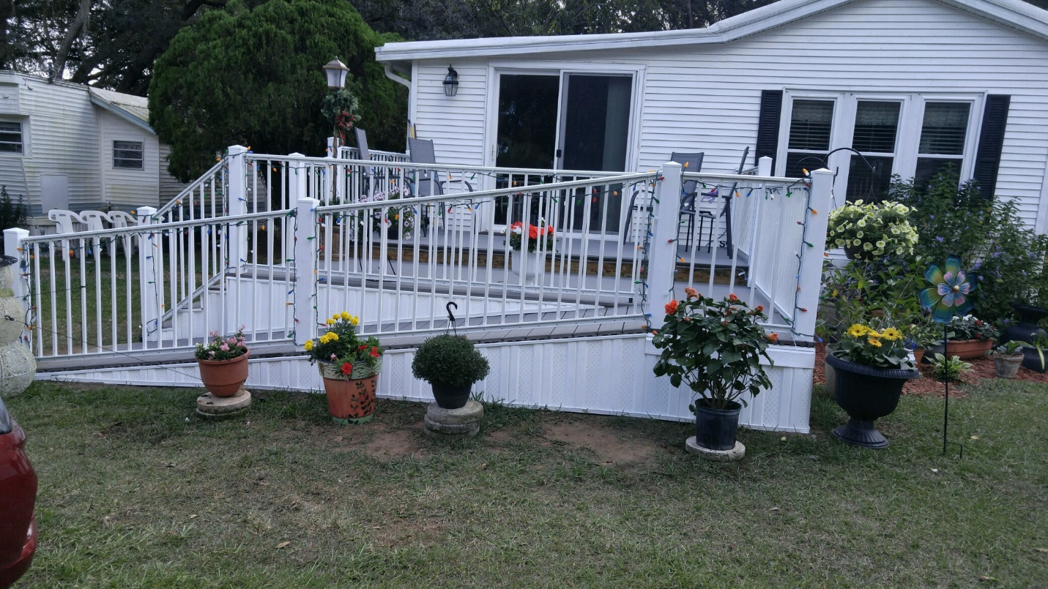

FOR SALE: 39406 Dancers Lane $57,500
A 1995 one-bedroom park model with a comparable size addition that includes a spacious living room and second bedroom that has been maintained in excellent condition. All appliances and park share are included in the sale price; furniture is negotiable.

Amenities include:
-laminate flooring in both bedrooms
-ceiling fans in both bedrooms, the living room and sitting room
-newer glass top stove
-newer bathroom vanity and comfort height toilet
-stackable washer and dryer
-replacement windows with lifetime warranty
-storage shed at back of lot

In the 2015/16 time frame the following upgrades were made:
-new linoleum in kitchen, hallway and bath
-new carpet in dining room, sitting room and living room.
-new fiberglass, walk in shower with safety bars and seat

In 2017 the kitchen was upgraded with new cupboards, countertops, cast iron sink, faucets, refrigerator and microwave, plus a new dining room light fixture. Also, in 2017 a new, spacious, composite material deck with both stairs and ramp was added to the front of the home. A new rear entry security door was installed in 2018.

If interest, contact Jerry Burghdorf to arrange a tour.

